B) Curvature flow: Output will be more displaced at points with more curvature.

The curvature value at points is very small so the no of iterations for each step taken is 100.

Curve 1: Random curve draw in paint

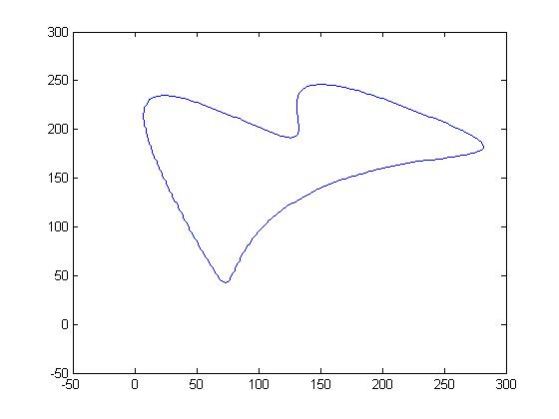

After 100 iterations

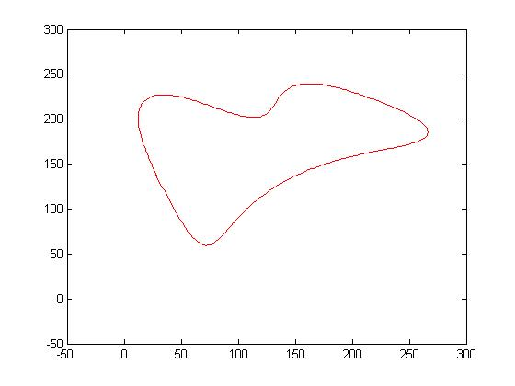

After 200 iterations

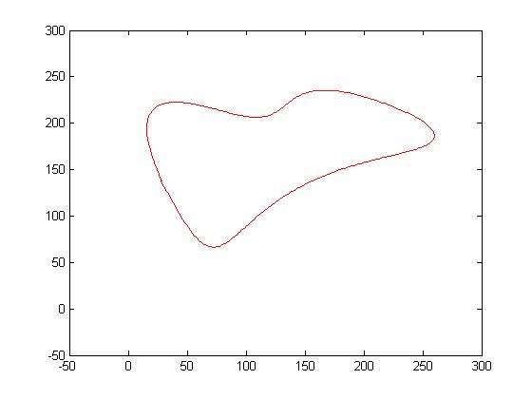

After 300 iterations

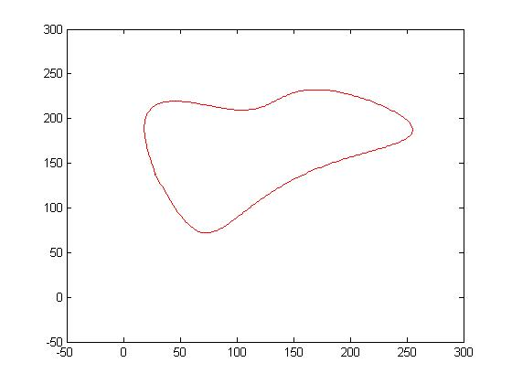

Curve 2: Pacman

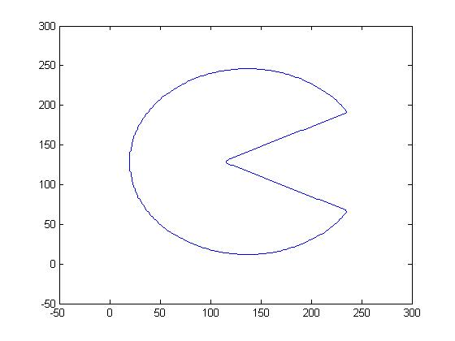

After 100 iterations

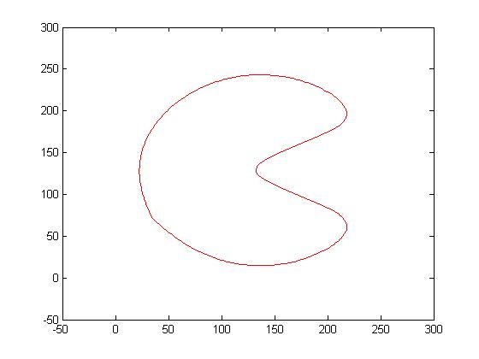

After 200 iterations

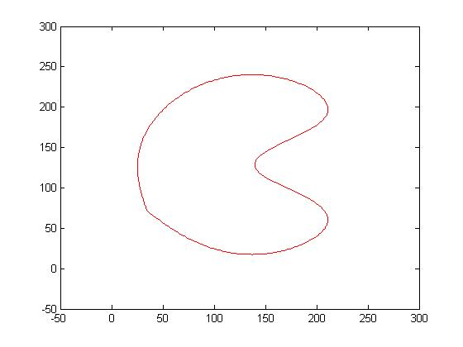

After 300 iterations

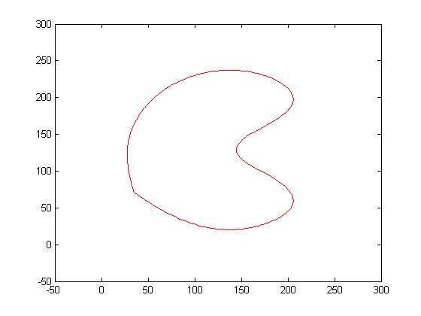

Curve 3: Circle. After 100 iterations.

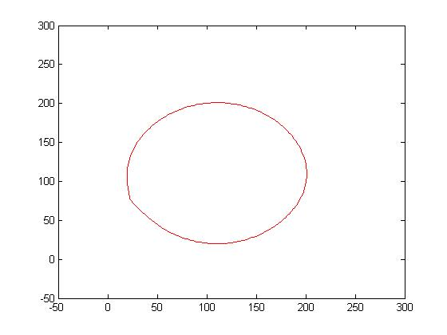

After 200 iterations.

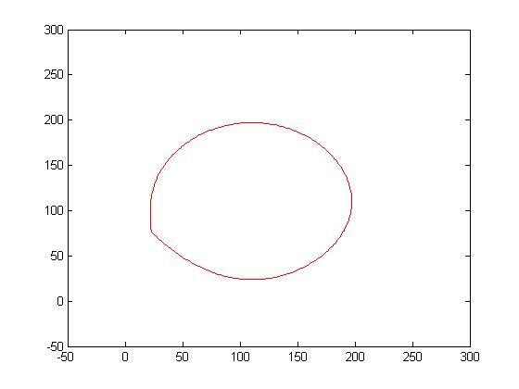

After 300 iterations.

